Name: Carl John Pactao-in
Course and Section: 1 BSInfoSys – A
Website Title: Barangay Malongon Official Website
Website URL: https://barangay-malongon.000webhostapp.com/
Final Project Repo URL: https://github.com/CarlHernan/IntroToComputing-Website-Project.git
Challenges Repo URL: https://github.com/CarlHernan/IntroToComputing-Challenges.git

The primary objective of the Barangay Malongon Official Website is to act as an informative and user-friendly platform catering to the residents and stakeholders of Barangay Malongon. With a structure encompassing seven pages—ranging from the home page, about page, daily updates, certificates, and profiling services to news, frequently asked questions (FAQ), and an intriguing Peek and See page—this website aims to deliver crucial information about barangay services, keep everyone abreast of the latest news, and address common queries. It's designed with simplicity and accessibility in mind, ensuring that everyone can easily navigate and benefit from the wealth of information it provides.
HOME PAGE
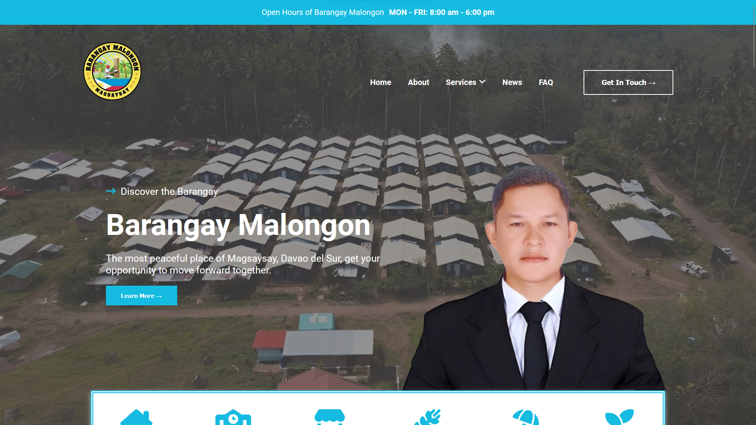

*Loading the images may took longer depending in your internet speed.

